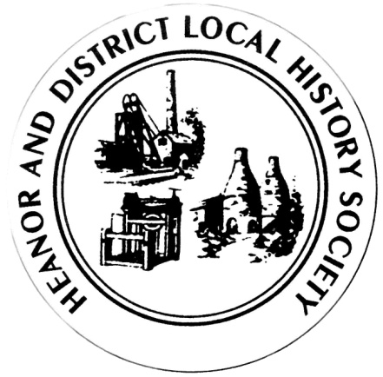
We want your memories! As part of an ongoing project, the Heanor & District Local History Society wants to hear from YOU.
We would like to establish a collection of people’s memories about the area - it can be from any period, and from any part of the district. And ANY subject - whether home life, work life, shopping, leisure. It doesn’t matter how trivial you may think your reminiscences are; they will help form part of a much bigger picture, which we can use to assist our future research, publications and newsletters.
This is nothing new of course; we have always asked for this from our members, but have now decided to use this method to try to prompt people to give information on specific issues.
So, every couple of months we will distribute a new form, on a different topic, and with different questions. There is no deadline. You don’t have to take part in all, or any, of the topics. Likewise, you don’t have to be a member to take part - all that we ask is that it is something to do with the Heanor area – from Codnor to Langley Mill, Smalley and Shipley. If you can think of someone else who may like to help, please feel free to pass a form onto them.
This month’s topic is: School Memories
How to pass the information onto us:
- If you normally attend our meetings, just fill in the form and hand it back at the next meeting.
- If you don’t attend our meetings, please send us an email with the information (mail@heanorhistory.org.uk).
We would rather that you didn’t send us information anonymously, but nobody’s name will be published unless you have specifically given us permission to do so. In particular, we WILL NOT publish anything which of a personal or potentially sensitive nature.
Name | Address
Telephone
Email address
Are you willing for your name to be linked to any information supplied? |  | Yes / No
Would you be prepared to discuss this or related information further? |  | Yes / No

P.T.O.

This time, we would like you to share your memories of school – but we would like you to focus on just one school you went to, rather than trying to summarise all your memories (though there’s nothing to stop you filling in more than one form!).
Which school do you have the most vivid memories of?
Roughly when was this, and what age were you?
Whose class(es) were you in? What do you remember about them?
(There may not be enough space for your answer – please feel free to use a separate sheet.)
Please describe a specific classroom as you remember it (and tell us which classroom it was).
Which other staff can you name (and, if applicable, what subject did they teach)?
Your memories of school dinners?
Please describe one incident which stands out in your memory?
Please complete a separate sheet for a different school if you like, and use separate sheets if necessary. If you have any school-related photographs, we would love to see them. Thank you

